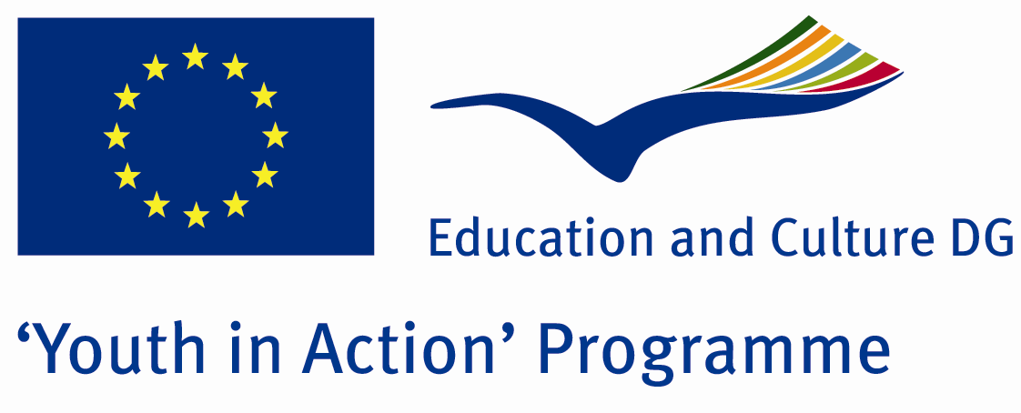

Married and Happy

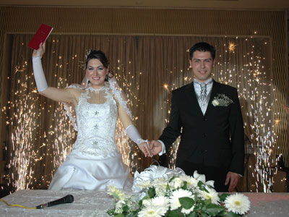

ACTION 1.1 – Youth Exchange

13-20th August, 2011

Edirne, TURKEY

ACTION 1.1 Youth Exchange
13-20th August, 2011
Edirne, TURKEY

Please contact directly to;
adventurerpeacepigeons@gmail.com

Project Summary;

We will introduce our wedding ceremony in our project. We aim that we provide our guests to tell our culteral wedding ceremony. We belive that the wedding ceremony is the best day in whole life because when people undertand to find his/her soul mate, he/she starts to imagine his/her wedding ceremony and he/she wants to organize the best wedding ceremony, we think it is the same all over the world. But in this wedding ceremony has been a little diversity because of the each others culterals. Moreover we will indicate our real wedding ceremony with this project. At the end of this may be our guests invite our groups to our wedding ceremony. With this project we and our guests will learn each others culture.

Project Title; Married and Happy

Date and Venue ; 13-20th August, 2011 Edirne, Turkey .

Target Group ; Municipalities, City Councils and Non-Governmental organizations,
youth groups,culture and art groups,e.t.c

Participants ; 5 people from each country (over 18 -25 ). Totally 8 countries.

Conditions ; Accommodation, board and programme costs will be financed through European Commission Youth in Action Programme (Action 1.1). Travel costs will be reimbursed in 70% (APEX Tarrifs). Organizations from all 27 EU member countries plus Liechtenstein , Norway and Iceland are eligible to take part.

Working language: English

Organizer; Adventurer Peace Pigeons

How to apply: If you are interested, please send your Part III forms to
0090 216 494 39 98 by FAX please. (Fulfilled Part III which you can find in the attachment, of course signed and stamped) ..

Note: jpeg is not allowed..please send by fax…

Next step 2;
Original send via regular post to this address please:

Ertan DERİN
Öner İnşaat
Abdulhalik Renda Cd.
Parlar Sk. No:4 Pendik/İSTANBUL

If you have any questions you may contact with: adventurerpeacepigeons@gmail.com

Deadline for application; until 20 March 2011.

For Further information:
Contact Person
Ertan DERİN
Öner İnşaat
Abdulhalik Renda Cd.
Parlar Sk. No:4 Pendik/İSTANBUL

e-mail : adventurerpeacepigeons@gmail.com
Mobile : 0090 542 393 93 90
Fax : 0090 216 494 39 98

